Read two streams

1. List of strings input by user

2. Real-time set of offensive words

Find the word count of the offensive words inputted by the user as per the

real-time set of offensive words.

Solution

In this assignment we are going to read the string which is captured in a port using **netcat** and hence we are installing the **netcat** in our server

Command : **sudo yum install nc**

Screen shot

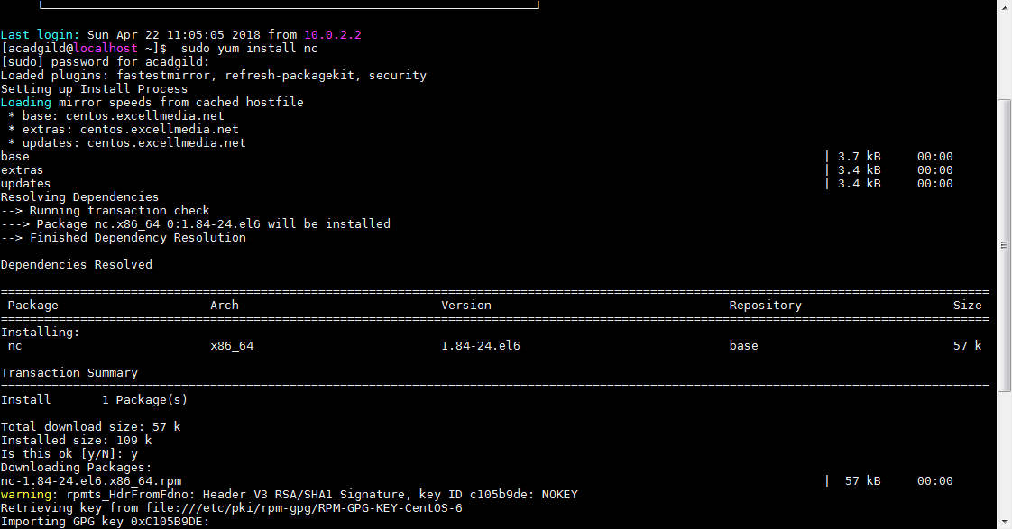

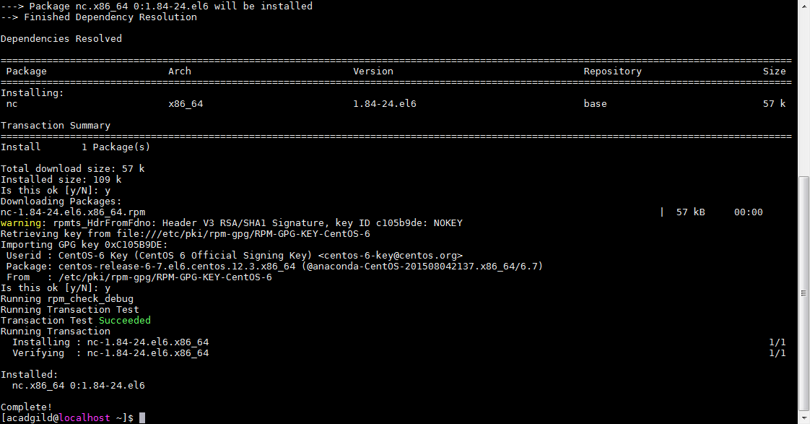

Start listening the port 9999 using the below command,

**nc -lk 9999**

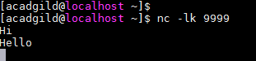

Start Spark shell with multi threads, in this case we are taking 4 multi threads.

**spark-shell --master local[4]**

# Read Two Streams – Spark Streaming

## Step – 1 - Import all the spark streaming packages

import org.apache.spark._

import org.apache.spark.streaming._

import org.apache.spark.streaming.StreamingContext._

